NAME: Yaw Ofosu Ansong (Jnr)
REGISTRATION NUMBER: SM/SMS/09/0028
COURSE: MBChB
DATE OF EXPERIMENT: Friday, September 25, 2009
GROUP NUMBER: GROUP 14
DETERMINATION OF THE DENSITY OF WATER USING A LOADED TEST-TUBE
AIM: 1) To determine the density of water using a loaded test-tube.
2) To determine the acceleration due to gravity from the periodic time for the loaded test tube to complete four oscillations.
APPARATUS: A wide test-tube filled with a graph strip marked at 2 cm intervals, a deep beaker, some lead shots, set of weights, calipers, water and stop watch.
DIAGRAM OF SETUP
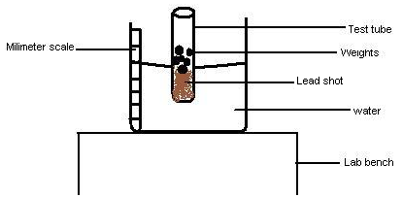
METHOD
Sufficient lead shot was placed in a test-tube. The test tube was then placed in a deep beaker half filled with water and fitted with a strip of graph paper marked at 2cm interval from the bottom to top. The test tube was made to float vertically by adjusting the water level. The level X₀ at which the test tube floated and became vertically erect and had just lifted above the base of the beaker was then noted using the millimeter scale on the beaker. A weight of 1 g was placed in the tube to make it sink to the bottom again. Water was then added carefully to the deep beaker till the test tube floated vertically erect. Addition of water was stopped just when the base of the test-tube lifted from the base of the beaker. The reading (x) of the scale against the water level was noted. The experiment was then repeated with each successive experiment having an additional mass of 1g more than the former till the mass of the test tube was 5g. A graph of the depth of immersion (d) = (X-X₀) against the additional load was then drawn. The external diameter of the test-tube was then found by employing the use of the vernier caliper. Four readings of the diameter of the test tube were taken and the average found in order to ensure a high degree of accuracy. The average diameter was then divided by 2 in order to find the radius of the test-tube.
The test tube was then caused to execute 10 complete vertical oscillations by displacing it vertically in the water from its initial position. The time for 10 complete oscillations was found using a stop watch. This procedure was repeated four times. From the periodic time T, the value of g, which is acceleration due to gravity, was found.
THEORY
Dictionary
radius of test-tube = r cm
mean depth of immersion = n cm/g = slope of the graph of the depth of immersion against additional load
density of water = w gm¯³
L = load
Volume of liquid displaced by addition of 1 gram to the test tube = ∏r²ncm³
Weight of liquid displaced = ∏r²n w gm
Hence by Archimedes’ principle: ∏r² n w = 1
Then the density of water w = (∏r² n) ¯¹ gcm¯³
but n = d/L
therefore w = [∏r² (d/L)] ¯¹
w = L/(∏r² d) , this implies that L = w x ∏r² d
w = L x (w x ∏r²)¯¹
Comparing with the general equation of a straight line y = mx + c
c = intercept = 0 , y = vertical component = d, X = horizontal component = L , m = slope = (w x ∏r²)¯¹
The motion is thus a simple harmonic motion with periodic time T
∏
T² = 4∏ x
g =
SKETCH OF EXPECTED GRAPH
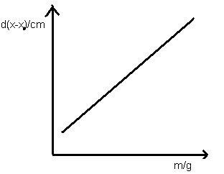
OBSERVATION.
The data obtained during the experiment has been tabulated below. d was calculated by subtracting 12.4 from X/cm. m/g is an independent variable since the masses are known.
X₀ = 12.4 cm

X/cm | d(x-12.4)/cm | m/g
12.8 | 0.4 | 1
13.4 | 1.0 | 2
14.0 | 1.6 | 3
14.6 | 2.2 | 4
15.2 | 2.8 | 5

t₁/s | t₂/s | t₃/s | t₄/s | t=[( t₁+ t₂+ t₃+t₄)/4]/s | T= (t/10)/s
7.07 | 7.12 | 6.69 | 6.82 | 6.925 | 0.6925
Average of diameter = (20.48+20.49+20.49+20.49)/4 = 20.4875cm
Therefore Radius of test-tube = L = half of diameter of test tube = (20.4875/2) = 10.24375 cm
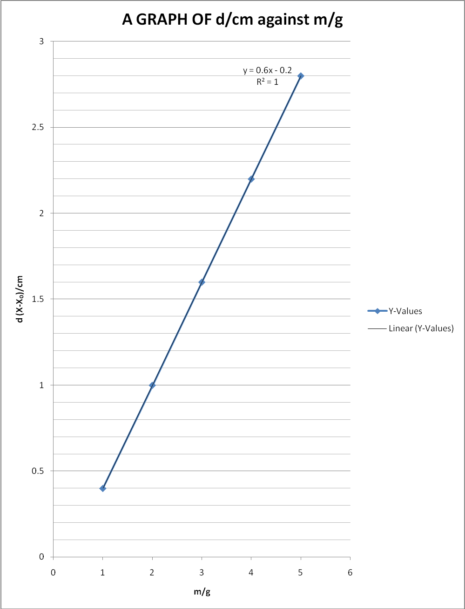
Comparing the equation of the line y= 0.6x – 0.2 to the general equation of a straight lime y= mx + c , the gradient of the line is deduced to be 0.6 cmg¯¹ and the intercept – 0.2
Therefore n = 0.6 cmg¯¹
Density of the liquid w = (∏ x (10.24375)² x 0.6) ¯¹
w = (197.7967106) ¯¹ = 5.055 x 10¯³ g cm¯³ = 5.055kgm¯³
Also, ²l/ T² but l=X- d
Therefore, 4² (0.152 0.028)/ (0.6925)², =10.208m/s²
Discussion of results.
From theory, as mass increases, density increases thereby increasing displacement in water. Theoretically therefore, a graph of displacement against mass should be a straight line with positive gradient. The graph obtained from the experiment is that of a straight line with positive gradient of 0.6 cmg¯¹. This is therefore in line with the theory of the experiment. From the experimental theory also, the intercept on the vertical axes should be 0, but from the graph obtained from the experiment, the intercept was found to be -0.2. This difference can be attributed to errors made during the experiment. The experimental value of the acceleration due to gravity was found to be 10.208m/s². However, the standard known value for acceleration due to gravity is 9.8 ms¯². The experimental value of the acceleration due to gravity therefore had an error of about 4%. From the experiment, the density of water was found to be 5.055 x 10¯³ g cm¯³, but from theory, the density of water is known to be 1.0 g cm¯³. It is noteworthy that the density of water is dependent on temperature. The density of 1.0 g cm¯³ is therefore the maximum density of water and this was determined at 4°C. The experiment was however conducted at a temperature of about 27°C. This therefore accounts to a large extent for the differences between the experimental and standard value obtained. Also, the laboratory in which the experiment was conducted was on the third floor of a storey building. The pressure therefore in the room was lower than the normal atmospheric pressure of 1 atm since pressure increases with depth. The theoretical value was however determined at an atmospheric pressure of 1 atm. This also accounts for the differences in the values obtained. From the experiment, we can also deduce that, from 4°C (since water expansion is anomalous) the density of water is inversely proportional to temperature whilst the density of water is directly proportional to atmospheric pressure. The experiment can be performed better by the use of modern optical instruments in order to achieve a higher precision in the determination of floating levels of the loaded test-tube. More accurate results can also be achieved by the use of sufficiently pure water.
Sources of error
1) Due to the refraction of light in the water, it was a daunting task in determining the level at which the test-tube floats. There was therefore to some extent a low precision in the determination of the floating levels of the test-tube.
2) The water used for the experiment was not sufficiently pure water. This to some extent accounts for the differences between the experimental value and the standard known value of acceleration due to gravity.
Precautions.
1) The test tube was displaced slightly in the water and was not subjected to forced motion in the determination of the time for 10 vertical oscillations. This was done in order to obtain the actual time for 10 vertical oscillations and therefore to ensure accurate results.
2) Error due to parallax was avoided in reading from the millimeter scale on the beaker.
3) Water was added carefully to the beaker in order to avoid splashing of the water into the test-tube containing the lead shot. This was also done carefully in order to avoid clinging of water to the sides of the beaker which could affect the accuracy of the results.
Conclusion: Within the limits of experimental error, the acceleration due to gravity was found to be 10.208m/s² (with an error of about 4%) and the density of water 5.055 x 10¯³ g cm¯³ at 27°C.

